

**SCHOOL OF BUSINESS AND ECONOMICS**

**DEPARTMENT OF BUSINESS TECHNOLOGY**

**DATABASE MANAGEMENT SYSTEM**

**Project Name:**

**TALENT MANAGEMENT SYSTEM**

**Student name: NYANGOMA ANNET MUKABARISA**

**Reg No: 222001557**

**Section I**

**1. Describe all the entities and their corresponding attributes that are in your database.**

**Applicant: This entity represents an individual who has applied for a job opening. The attributes of this entity may include applicant ID, name, contact information, resume, cover letter, and application status.**

**Recruitment: This entity represents the process of hiring new employees. The attributes of this entity may include job requisition number, recruiting source, interview notes, and offer letter.**

**Performance review: This entity represents the process of evaluating employee performance. The attributes of this entity may include performance goals, ratings, and feedback.**

**Employee: This entity represents an individual employee. The attributes of this entity may include employee ID, name, contact information, job title, department, date of hire, education, skills, and experience.**

**Job: This entity represents a job opening in the organization. The attributes of this job may include job title, department, location, responsibilities, qualifications, and salary range.**

**2. Create an LDM of your entities**

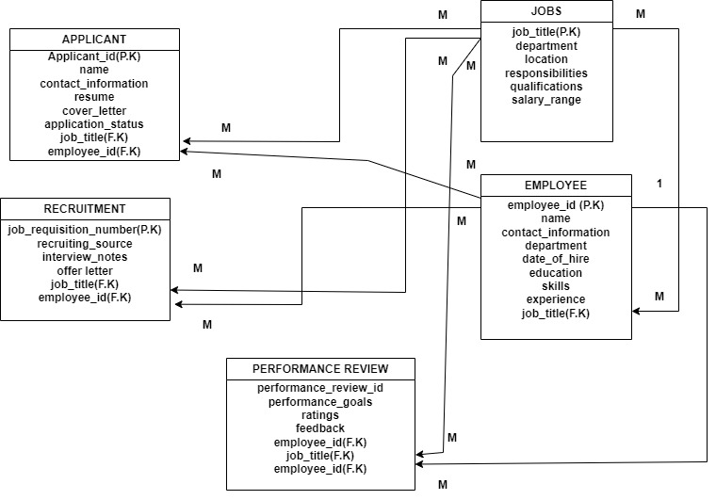

**3. Create an ERD**

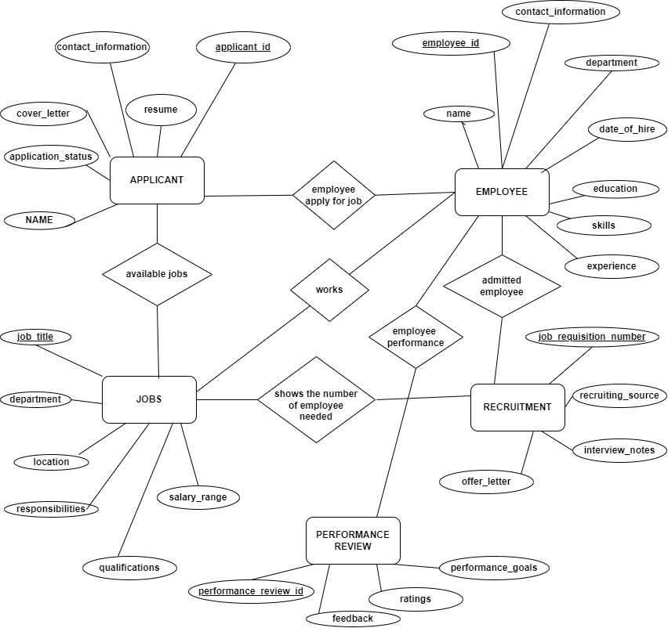

**Section II SQL**

**1. Create the database of your system**

**CREATE DATABASE TALENT_MANAGEMENT_SYSTEM;**

**2. Write queries to create all the tables and relationships of your system**

**CREATE TABLE employees (**

**employee_id INT NOT NULL AUTO_INCREMENT,**

**name VARCHAR(255) NOT NULL,**

**contact_information VARCHAR(255) NOT NULL,**

**job_title VARCHAR(255) NOT NULL,**

**department VARCHAR(255) NOT NULL,**

**date_of_hire DATE NOT NULL,**

**education VARCHAR(255) NOT NULL,**

**skills VARCHAR(255) NOT NULL,**

**experience VARCHAR(255) NOT NULL,**

**PRIMARY KEY (employee_id)**

**);**

**CREATE TABLE jobs (**

**job_title VARCHAR(255) NOT NULL,**

**department VARCHAR(255) NOT NULL,**

**location VARCHAR(255) NOT NULL,**

**responsibilities VARCHAR(255) NOT NULL,**

**qualifications VARCHAR(255) NOT NULL,**

**salary_range INT NOT NULL,**

**PRIMARY KEY (job_title)**

**);**

**CREATE TABLE applicants (**

**applicant_id INT NOT NULL AUTO_INCREMENT,**

**name VARCHAR(255) NOT NULL,**

**contact_information VARCHAR(255) NOT NULL,**

**resume VARCHAR(255) NOT NULL,**

**cover_letter VARCHAR(255) NOT NULL,**

**application_status VARCHAR(255) NOT NULL,**

**PRIMARY KEY (applicant_id)**

**);**

**CREATE TABLE recruitments (**

**job_requisition_number INT NOT NULL AUTO_INCREMENT,**

**recruiting_source VARCHAR(255) NOT NULL,**

**interview_notes VARCHAR(255) NOT NULL,**

**offer_letter VARCHAR(255) NOT NULL,**

**PRIMARY KEY (job_requisition_number)**

**);**

**CREATE TABLE performance_reviews (**

**performance_review_id INT NOT NULL AUTO_INCREMENT,**

**employee_id INT NOT NULL,**

**job_title VARCHAR(255) NOT NULL,**

**performance_goals VARCHAR(255) NOT NULL,**

**ratings VARCHAR(255) NOT NULL,**

**feedback VARCHAR(255) NOT NULL,**

**PRIMARY KEY (performance_review_id),**

**FOREIGN KEY (employee_id) REFERENCES employees (employee_id)**

**);**

**ALTER TABLE performance_reviews**

**ADD CONSTRAINT fk_performance_reviews_job_title**

**FOREIGN KEY (job_title) REFERENCES jobs (job_title);**

**3. write queries to insert data into your tables.**

**INSERT INTO employees (name, contact_information, job_title, department, date_of_hire, education, skills, experience)**

**VALUES ('John Doe', 'john.doe@email.com', 'Software Engineer', 'Engineering', '2023-03-08', 'BS in Computer Science', 'Java, Python, SQL', '3 years');**

**INSERT INTO jobs (job_title, department, location, responsibilities, qualifications, salary_range)**

**VALUES ('Software Engineer', 'Engineering', 'Kigali, Rwanda', 'Design, develop, and test software applications', 'BS in Computer Science', 'USD 50,000 - 100,000');**

**INSERT INTO applicants (name, contact_information, resume, cover_letter, application_status)**

**VALUES ('Jane Doe', 'jane.doe@email.com', 'resume.pdf', 'cover_letter.pdf', 'Pending');**

**INSERT INTO recruitments (job_requisition_number, recruiting_source, interview_notes, offer_letter)**

**VALUES (123456, 'LinkedIn', 'Good candidate, but not the best fit for the role', NULL);**

**INSERT INTO performance_reviews (employee_id, job_title, performance_goals, ratings, feedback)**

**VALUES (1, 'Software Engineer', 'Meet all deadlines, maintain high code quality, and work well with others', 'Excellent', 'Great job!');**

**4. Write queries to display all the information in your tables.**

**SELECT * FROM employees;**

**SELECT * FROM jobs;**

**SELECT * FROM applicants;**

**SELECT * FROM recruitments;**

**SELECT * FROM performance_reviews;**

**5. Write a query to update information in any of the two tables of your system**

**UPDATE employees**

**SET job_title = 'Senior Software Engineer'**

**WHERE employee_id = 1;**

**UPDATE employees**

**SET job_title = 'Senior Software Engineer',**

**department = 'Engineering'**

**WHERE employee_id = 1;**

**Section III**

**1. Create a view to insert data into your tables.**

**CREATE VIEW all_employees AS**

**SELECT \***

**FROM employees;**

**INSERT INTO all_employees (name, job_title, department)**

**VALUES ('Jane Doe', 'Software Engineer', 'Engineering');**

**CREATE VIEW insert_job AS**

**SELECT * FROM jobs;**

**INSERT INTO insert_job (job_title, department, location, responsibilities, qualifications, salary_range)**

**VALUES ('Software Engineer', 'Engineering', 'Kigali, Rwanda', 'Design, develop, and test software applications', 'BS in Computer Science', 'USD 50,000 - 100,000');**

**CREATE VIEW insert_performance_review AS**

**SELECT employee_id,**

**job_title,**

**performance_goals,**

**ratings,**

**feedback**

**FROM performance_reviews;**

**INSERT INTO insert_performance_review (employee_id, job_title, performance_goals, ratings, feedback)**

**VALUES (1, 'Software Engineer', 'Meet all deadlines, maintain high code quality, and work well with others', 'Excellent', 'Great job!');**

**CREATE VIEW applicant_review_view AS**

**SELECT applicant_id, name, contact_information, resume, cover_letter, application_status,**

**(SELECT job_title FROM jobs WHERE job_title = applicant_review.job_title) AS job_title,**

**(SELECT performance_goals FROM performance_reviews WHERE performance_reviews.employee_id = applicant_review.applicant_id) AS performance_goals,**

**(SELECT ratings FROM performance_reviews WHERE performance_reviews.employee_id = applicant_review.applicant_id) AS ratings,**

**(SELECT feedback FROM performance_reviews WHERE performance_reviews.employee_id = applicant_review.applicant_id) AS feedback**

**FROM applicants applicant_review;**

**INSERT INTO performance_reviews (employee_id, job_title, performance_goals, ratings, feedback)**

**SELECT 1, (SELECT job_title FROM applicants WHERE applicant_id = 1), 'Meet all deadlines, maintain high code quality, and work well with others', 'Excellent', 'Great job!'**

**FROM applicant_review_view;**

**2. Create a view to display all the information in your tables.**

**CREATE VIEW all_info_view AS**

**SELECT \***

**FROM employees**

**UNION ALL**

**SELECT \***

**FROM jobs**

**UNION ALL**

**SELECT \***

**FROM applicants**

**UNION ALL**

**SELECT \***

**FROM recruitments**

**UNION ALL**

**SELECT \***

**FROM performance_reviews;**

**3. Create a view to update information in any of the two tables of your system.**

**CREATE OR REPLACE VIEW updatable_employee_info AS**

**SELECT employee_id, First_name, Last_name, phone_number, email, location**

**FROM employee;**

**UPDATE updatable_employee_info**

**SET name=’john doe'**

**WHERE lcation=’kigali’;**

**CREATE OR REPLACE VIEW updatable_applicant_info AS**

**SELECT applicant_id, name,contact_information,resume**

**FROM applicant;**

**UPDATE updatable_applicant_info**

**SET name='Jane Doe'**

**WHERE applicant_id=’01’;**

**4. Create a view to delete data in any two of your tables according to any simple condition of your choice.**

**CREATE VIEW delete_data_view AS**

**SELECT \***

**FROM employees**

**WHERE department = 'Engineering';**

**DELETE FROM performance_reviews**

**WHERE employee_id IN (SELECT id FROM delete_data_view);**

**CREATE VIEW delete_applicant_view AS**

**SELECT applicant_id**

**FROM applicants**

**WHERE application_status = 'Rejected';**

**5. In your database, create one view of your choice that considers sub-query.**

**CREATE VIEW applicants_with_high_salary_view AS**

**SELECT applicant_id, name, contact_information, resume, cover_letter, application_status, salary**

**FROM applicants**

**WHERE salary > (SELECT AVG(salary) FROM applicants);**

**Section IV**

**1. Create a stored procedure to insert data into your tables.**

**CREATE PROCEDURE insert_employee (**

**IN employee_name VARCHAR(255),**

**IN contact_information VARCHAR(255),**

**IN job_title VARCHAR(255),**

**IN department VARCHAR(255),**

**IN date_of_hire DATE,**

**IN education VARCHAR(255),**

**IN skills VARCHAR(255),**

**IN experience VARCHAR(255)**

**)**

**BEGIN**

**INSERT INTO employees (name, contact_information, job_title, department, date_of_hire, education, skills, experience)**

**VALUES (employee_name, contact_information, job_title, department, date_of_hire, education, skills, experience);**

**END;**

**2. Create a stored procedure to display all the information in your tables.**

**CREATE PROCEDURE show_all_employees ()**

**BEGIN**

**SELECT \***

**FROM employees;**

**END;**

**3. Create a stored procedure to update information in any of the two tables of your system.**

**CREATE PROCEDURE update_employee (**

**IN employee_id INT,**

**IN employee_name VARCHAR(255),**

**IN contact_information VARCHAR(255),**

**IN job_title VARCHAR(255),**

**IN department VARCHAR(255),**

**IN date_of_hire DATE,**

**IN education VARCHAR(255),**

**IN skills VARCHAR(255),**

**IN experience VARCHAR(255)**

**)**

**BEGIN**

**UPDATE employees**

**SET name = employee_name,**

**contact_information = contact_information,**

**job_title = job_title,**

**department = department,**

**date_of_hire = date_of_hire,**

**education = education,**

**skills = skills,**

**experience = experience**

**WHERE employee_id = employee_id;**

**END;**

**4. Create a stored procedure to delete data in any two of your tables according to any simple condition of your choice.**

**CREATE PROCEDURE update_employee (**

**IN employee_id INT,**

**IN employee_name VARCHAR(255),**

**IN contact_information VARCHAR(255),**

**IN job_title VARCHAR(255),**

**IN department VARCHAR(255),**

**IN date_of_hire DATE,**

**IN education VARCHAR(255),**

**IN skills VARCHAR(255),**

**IN experience VARCHAR(255)**

**)**

**BEGIN**

**UPDATE employees**

**SET name = employee_name,**

**contact_information = contact_information,**

**job_title = job_title,**

**department = department,**

**date_of_hire = date_of_hire,**

**education = education,**

**skills = skills,**

**experience = experience**

**WHERE employee_id = employee_id;**

**END;**

**5. In your database, stored the procedure view of your choice that considers sub-query**

**CREATE PROCEDURE get_applicants_with_high_salary ()**

**BEGIN**

**SELECT \***

**FROM applicants**

**WHERE salary > (**

**SELECT AVG(salary)**

**FROM applicants**

**);**

**END;**

**Section V**

**1. Create after inserting triggers for any two tables of your choice.**

**-CREATE TRIGGER after_insert_trigger**

**AFTER INSERT ON applicants**

**FOR EACH ROW**

**BEGIN**

**INSERT INTO recruitments (applicant_id, job_title)**

**VALUES (NEW.applicant_id, NEW.job_title);**

**END;**

**-CREATE TRIGGER after_insert_job**

**AFTER INSERT ON jobs**

**FOR EACH ROW**

**BEGIN**

**INSERT INTO job_log (job_id, job_title, department, description, created_at, updated_at)**

**VALUES (NEW.job_id, NEW.job_title, NEW.department, NEW.description, NEW.created_at, NEW.updated_at);**

**END;**

**2. Create after-update triggers for any two tables of your choice.**

**-CREATE TRIGGER after_update_job_salary**

**AFTER UPDATE ON jobs**

**FOR EACH ROW**

**BEGIN**

**IF NEW.salary > OLD.salary THEN**

**INSERT INTO salary_increase_log (job_id, old_salary, new_salary, updated_at)**

**VALUES (NEW.job_id, OLD.salary, NEW.salary, NOW());**

**END IF;**

**END;**

**-** **CREATE TRIGGER after_update_job_and_applicant**

**AFTER UPDATE ON jobs, applicants**

**FOR EACH ROW**

**BEGIN**

**IF NEW.job_title != OLD.job_title THEN**

**UPDATE applicants**

**SET job_title = NEW.job_title**

**WHERE job_id = NEW.job_id;**

**END IF;**

**END;**

**3. Create after deleting triggers for any two tables of your choice**

**-CREATE TRIGGER after_delete_job_and_applicant**

**AFTER DELETE ON jobs, applicants**

**FOR EACH ROW**

**BEGIN**

**INSERT INTO deleted_jobs (job_id, job_title, department, description, created_at, updated_at)**

**VALUES (OLD.job_id, OLD.job_title, OLD.department, OLD.description, OLD.created_at, OLD.updated_at);**

**INSERT INTO deleted_applicants (applicant_id, name, contact_information, resume, cover_letter, application_status, job_id)**

**VALUES (OLD.applicant_id, OLD.name, OLD.contact_information, OLD.resume, OLD.cover_letter, OLD.application_status, OLD.job_id);**

**END;**

**Section VI**

**1. Create a user with your name as username and your student number as password and grant all privileges to the created user.**

**mysql -u root -p**

**create user 'nyangomaannet'@'localhost'IDENTIFIED BY '222001557';**

**GRANT ALL PRIVILEGES ON *.* TO 'nyangomaannet'@'localhost';**

**FLUSH PRIVILEGES;**

**exit;**

**2. Create a user with your "names_semi" as username and your student number as password and give him insert, update, and delete privileges to the created user.**

**mysql -u root -p**

**CREATE USER 'nyangoma'@'localhost' IDENTIFIED BY '222001557';**

**GRANT INSERT, UPDATE, DELETE ON *.* TO 'nyangoma'@'localhost';**

**FLUSH PRIVILEGES;**

**exit;**

**3. Revoke insert privileges to the last user you created**

**mysql -u root -p**

**REVOKE INSERT ON *.* FROM 'nyangoma'@'localhost';**

**FLUSH PRIVILEGES;**

**exit;**